SIA "GRAVITIS ENTERPRISE LIMITED"
Lauku iela 7 - 4, Cēsis, LV-4101, Latvia

Technical Drawing Package
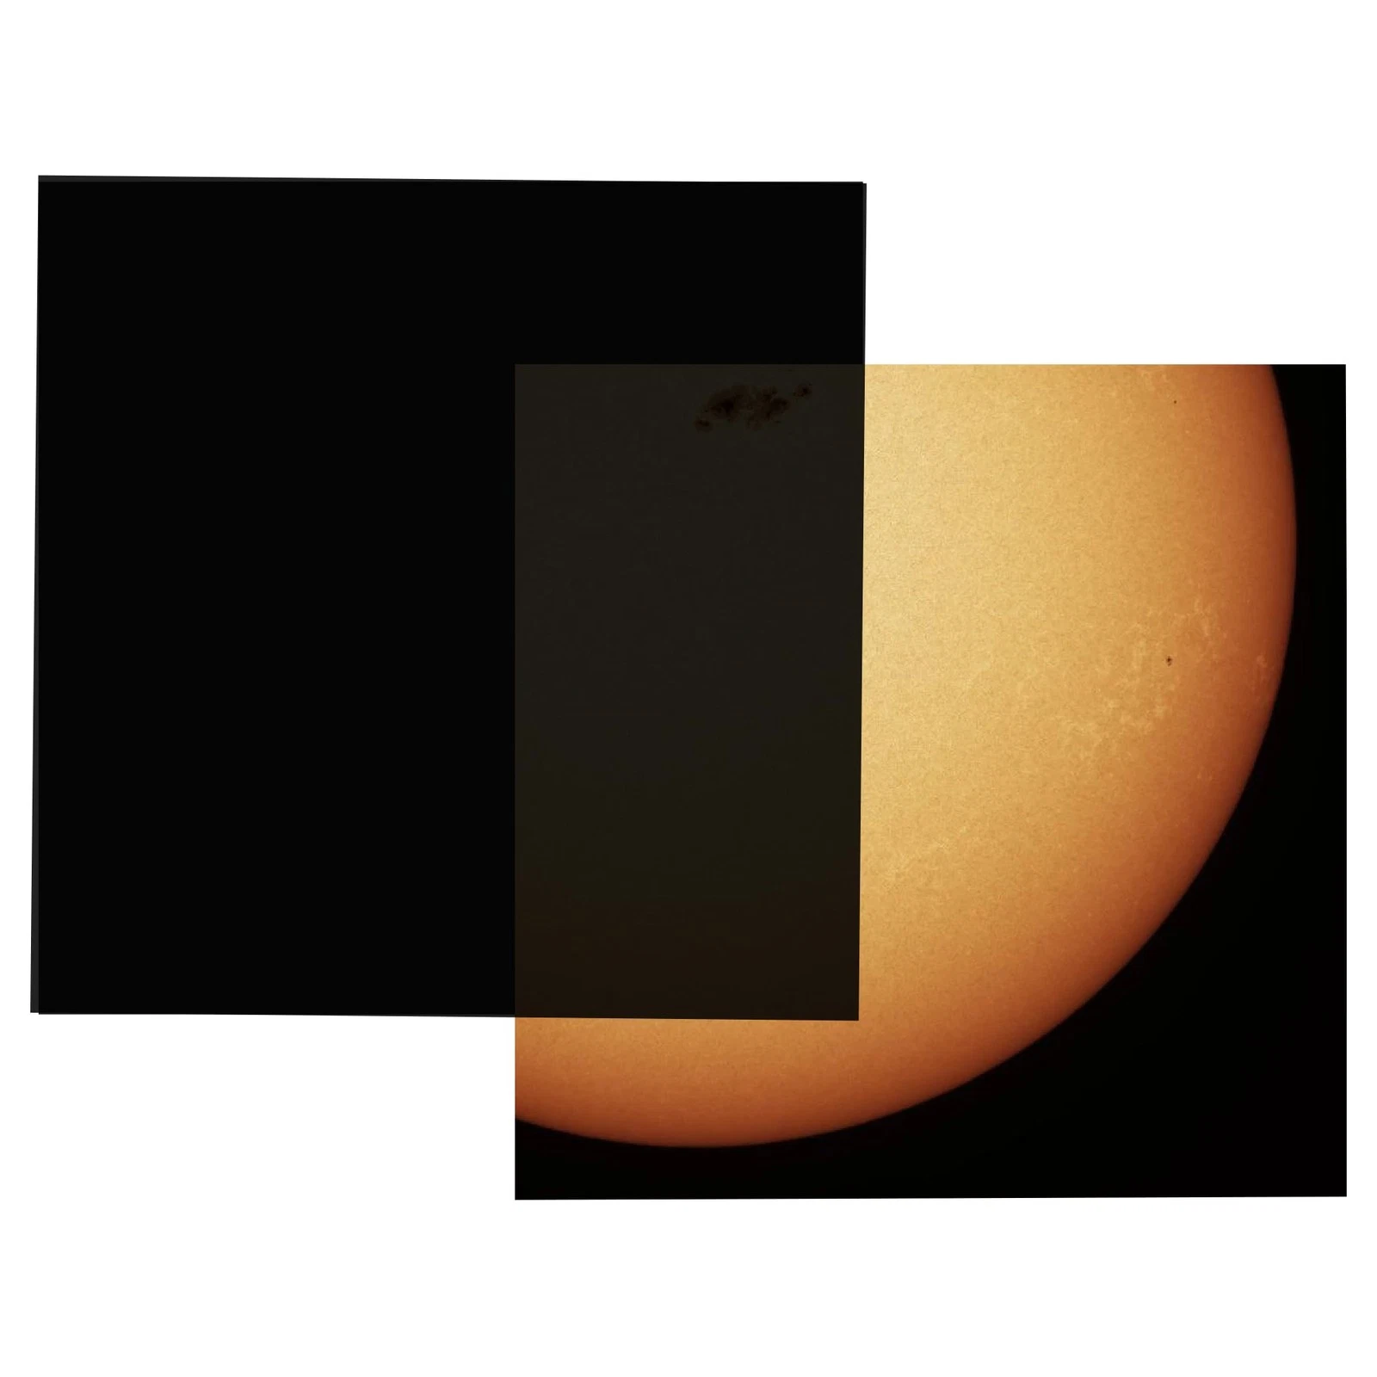

Solar Eclipse Filter Sheet (EGP-FIT-TDP)
Document Title: | Technical Drawing Package
Product | EclipsePro Plastic Glasses (EGP-FIT)
Document No.: | EGP-FIT-TDP-001
Revision: | A
Date: | 1/2/2026
Status: | FOR NOTIFIED BODY SUBMISSION

 |   Name | Signature | Date
Drawn By: | Māris Grāvītis |  | # TODO
Checked By: | Māris Grāvītis |  | # TODO
Approved By: | Māris Grāvītis |  | # TODO

Table of Contents
Revision History 2
Fabrication Specification (EFS-SHT-FAB-001) 3
Fabrication Specification (EFS-SHT-MRK-001) 5

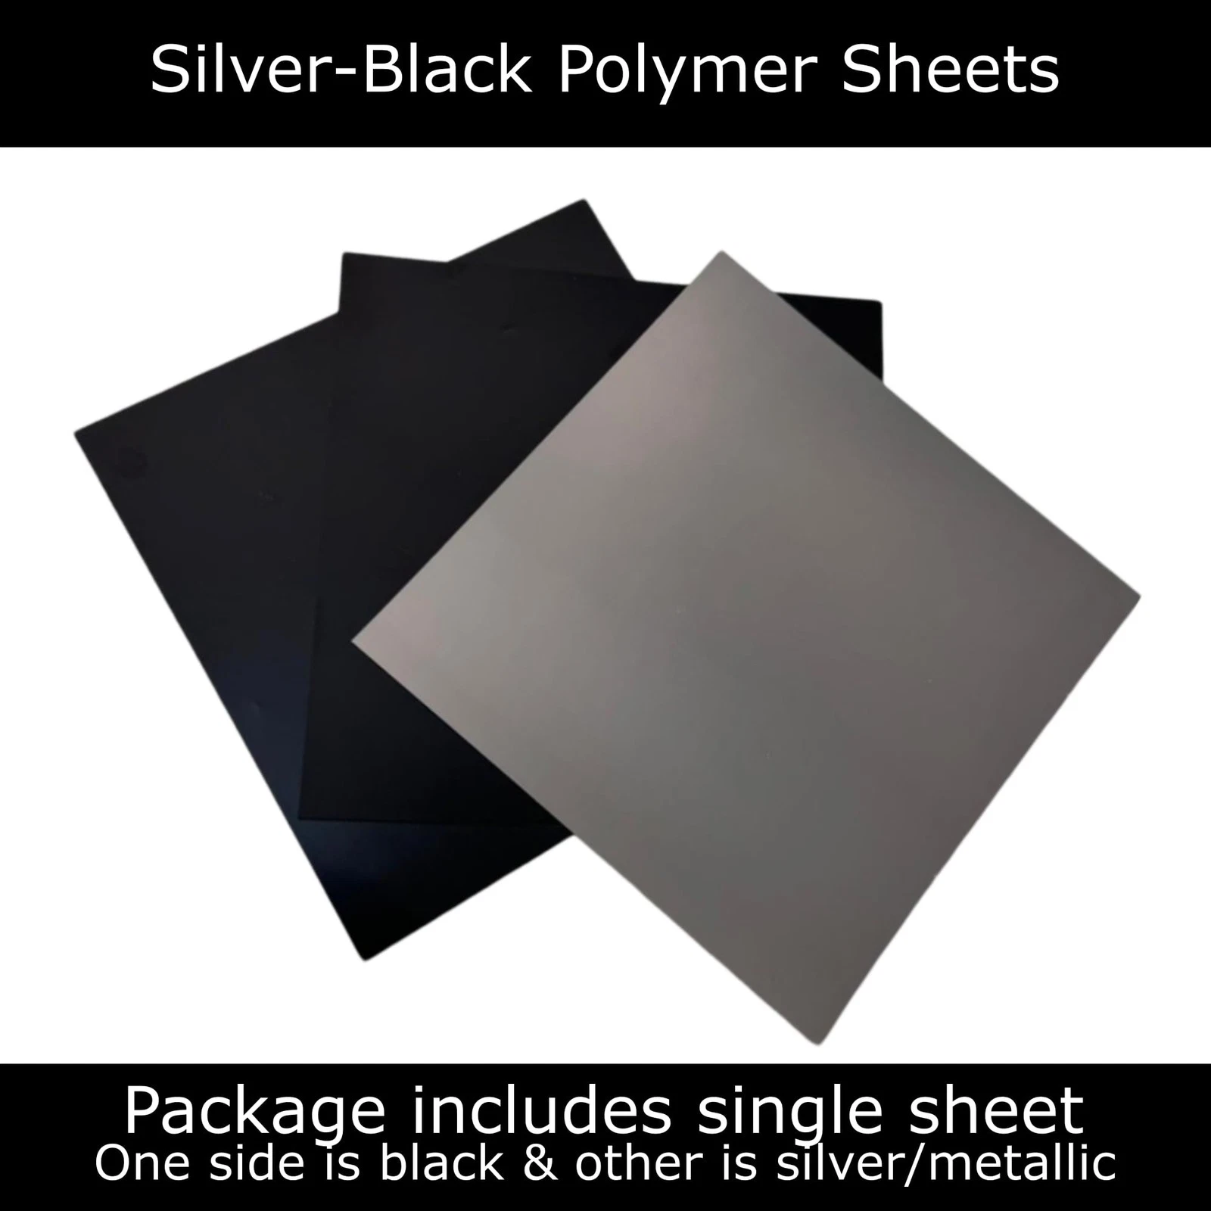

Revision History

Revision | Description Of Changes | Date | Approved By
A | Initial Release | 03/02/2026 | Māris Grāvītis

Fabrication Specification (EGP-SHT-FAB-001)
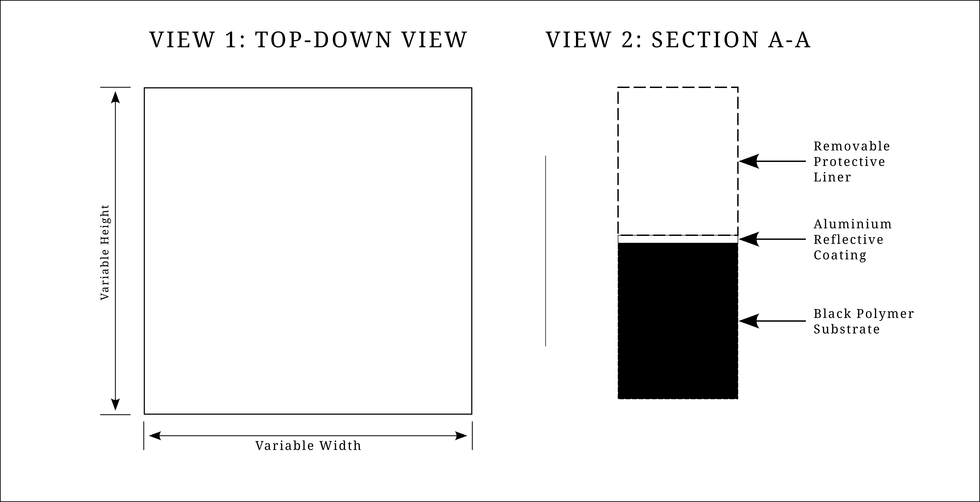
NOTES & SPECIFICATIONS:
- MATERIAL: Polymer substrate with Aluminium Reflective Coating.
  - Optical Density (OD) > 5.0.
  - Certified to EN ISO 12312-2:2015.
- ASSEMBLY ORIENTATION:
  - Aluminium (Reflective) Side: Faces the Sun.
  - Black (Substrate) Side: Faces the User/Eyes.
- PROTECTIVE LINER:
  - Removable opaque liner applied to the Aluminium surface.
  - Liner carries Safety & Regulatory markings (See Doc: EFS-SHT-MRK-001).
- TOLERANCES:
  - Linear Dimensions (W, H): ± 1.0mm.
  - Squareness: ± 1°.
- QUALITY CONTROL:
  - Optical surface must be free of scratches, pinholes, and delamination.
  - Edges must be clean cut and free of burrs.

Dimension | Min | Max
Variable Width (W) | 100mm (4”) | 305mm (12”)
Variable Height (H) | 100mm (4”) | 305 (12”)
Thickness | 0.12mm | N/A

STANDARD PRODUCT CONFIGURATIONS

Variant Code | Nominal Size (Metric) | Equivalent (Imperial) | Intended Use
EFS-SHT-4x4 | 100mm x 100mm | 4" x 4" | Camera / Small Telescope
EFS-SHT-6x6 | 150mm x 150mm | 6" x 6" | Medium Telescope / Binoculars
EFS-SHT-8x8 | 200mm x 200mm | 8" x 8" | Large Telescope
EFS-SHT-12x12 | 300mm x 300mm | 12" x 12" | Oversized / Custom Application
EFS-SHT-CUST | Custom* | Custom* | Defined by Customer Order

Marking Specification (EGP-SHT-MRK-001)
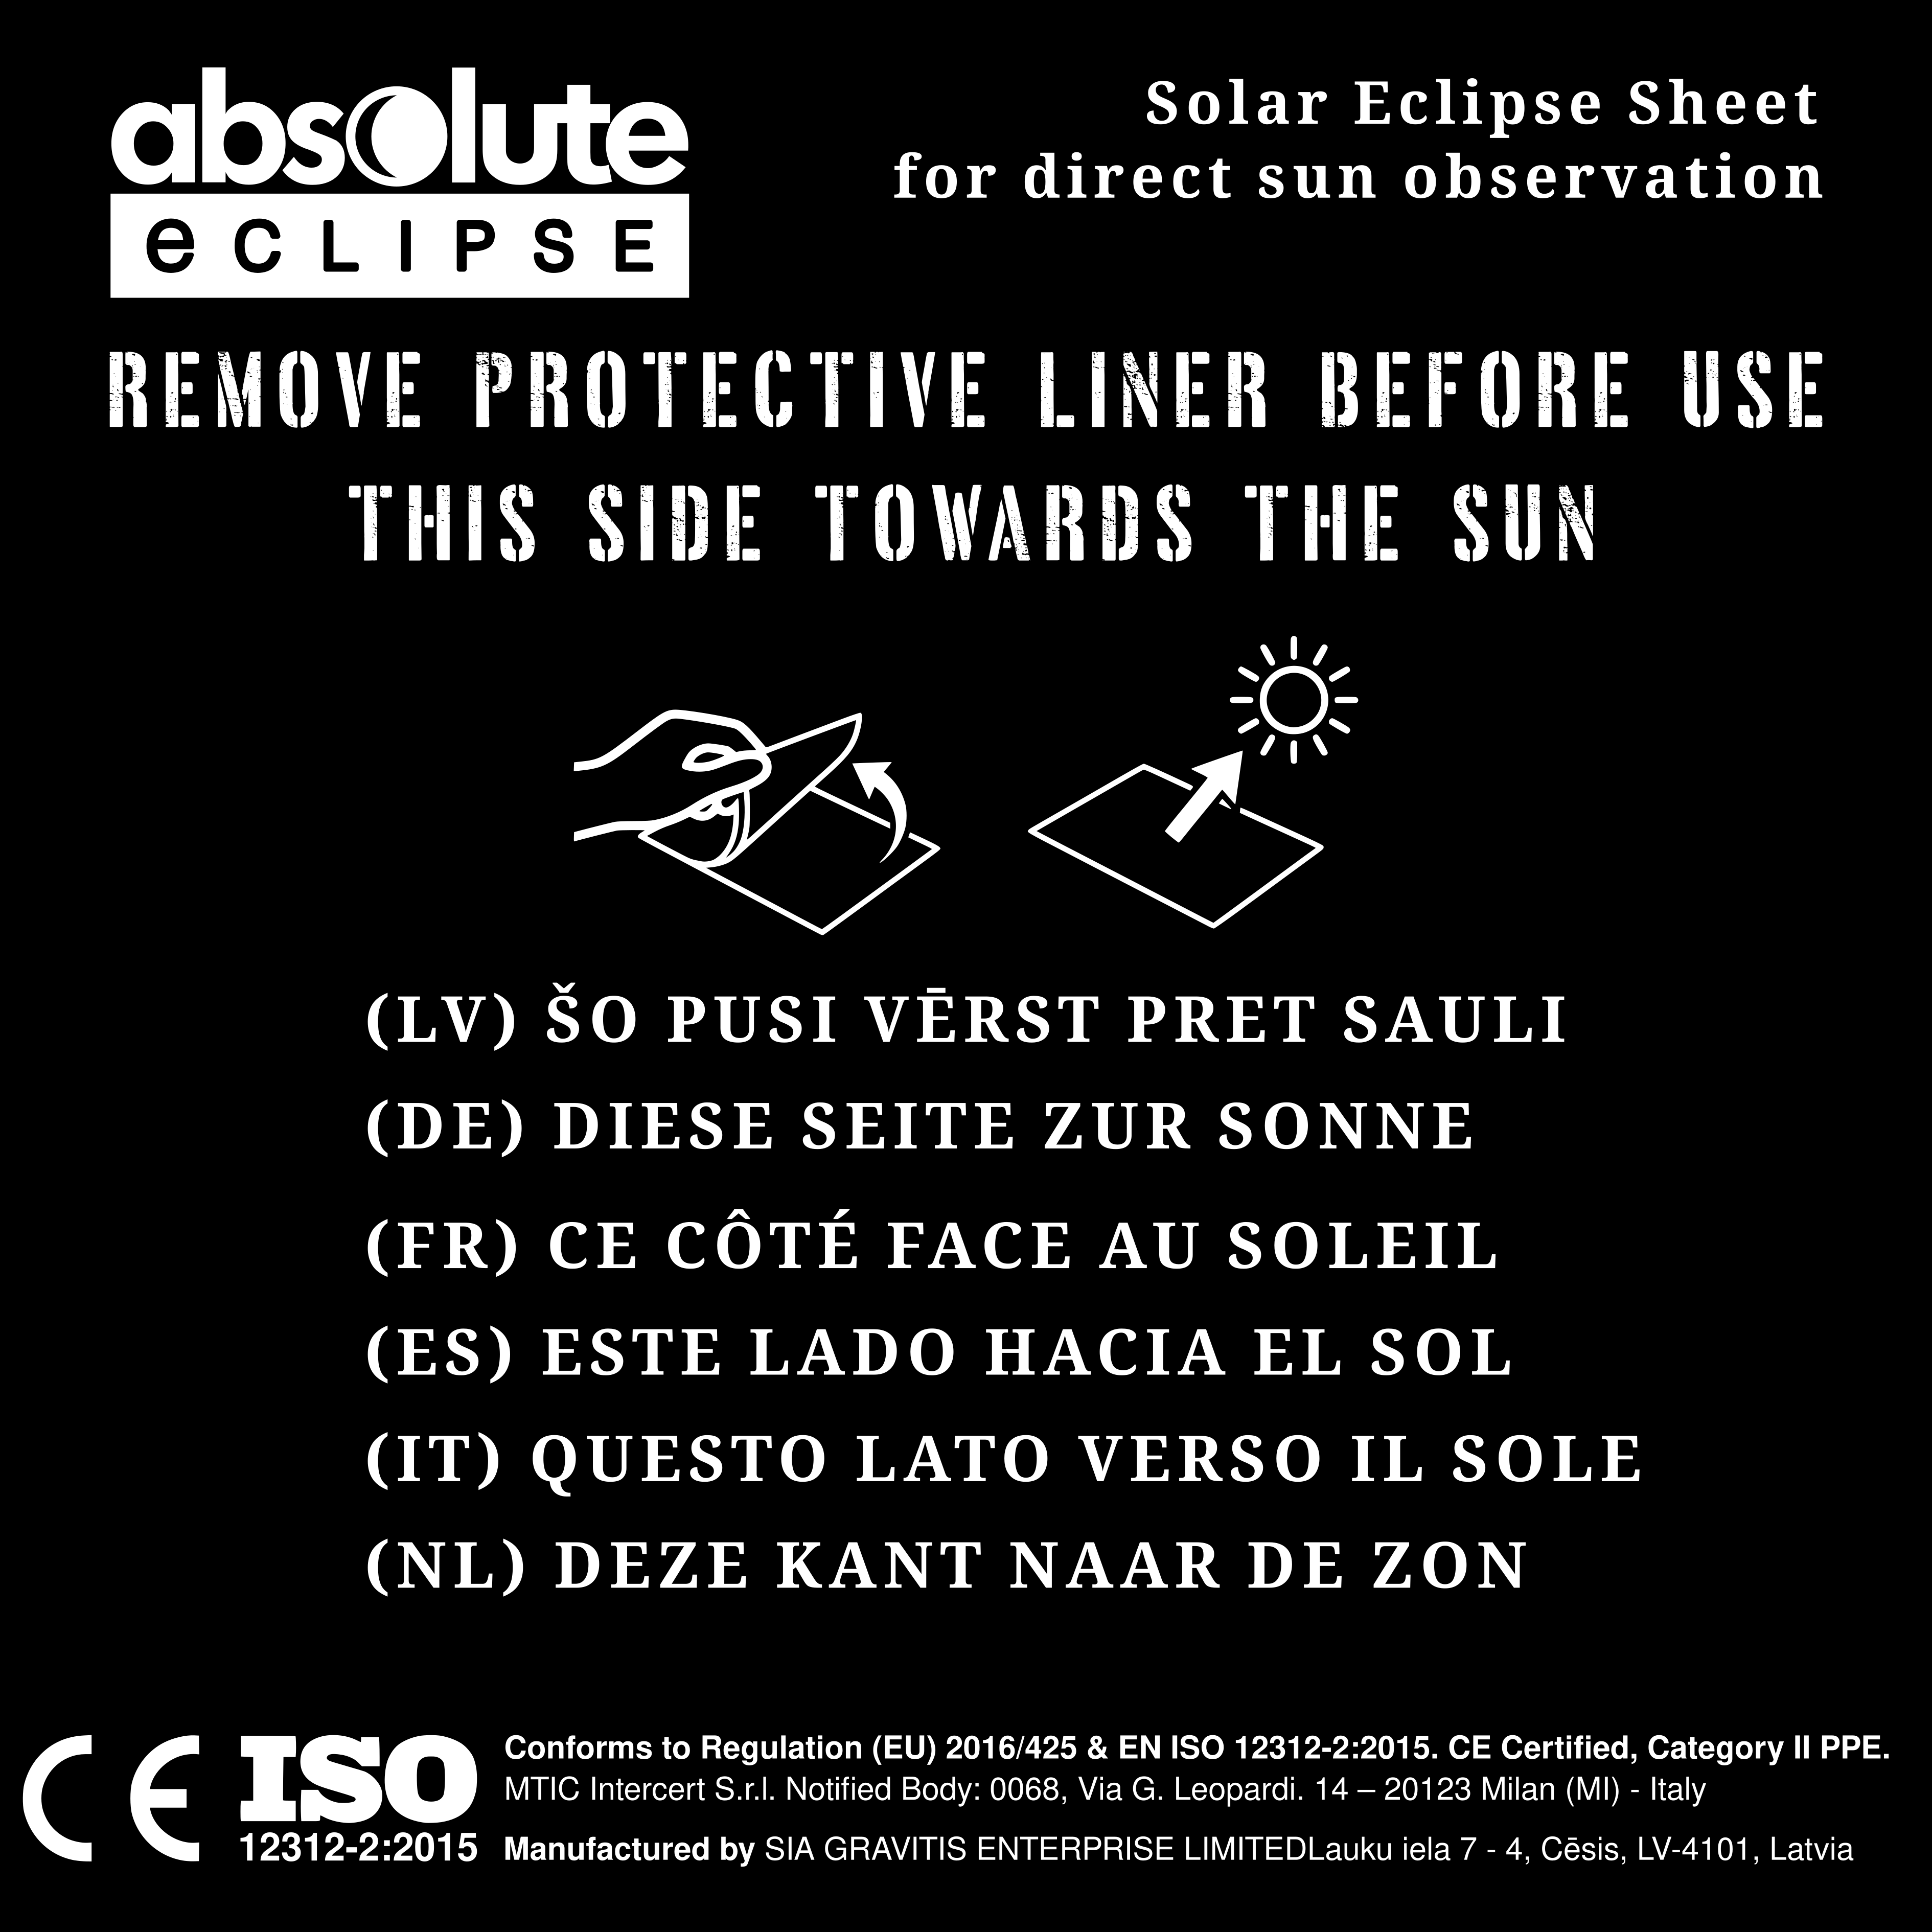
Marking Location
- Primary Location: Printed directly on the removable protective liner applied to the Silver (Sun-facing) side of the filter.
- Secondary Location: Repeated on the external retail packaging (Document PKG-SHEET OUTER-001).
The following table defines each element present in the marking artwork and acknowledges the applicable regulatory requirement.
# | Visual Element / Text | Description / Function | Regulatory Requirement / Acknowledgment
1 | Brand Logo & Text"Absolute Eclipse""Solar Eclipse Sheet" | Product Identification. Identifies the product type and brand family. | Reg (EU) 2016/425, Art 8(6): Requirement to identify the product type/model.
2 | Safety Imperative"REMOVE PROTECTIVE LINER BEFORE USE" | Critical Safety Instruction. Prevents the user from looking through the cloudy/printed liner, which would obscure vision and degrade optical quality. | EN ISO 12312-2, Clause 5(b): Instructions for use / warnings to ensure safe usage.
3 | Orientation Instruction"THIS SIDE TOWARDS THE SUN" | Safety/Orientation Warning. Instructs the user to orient the reflective (Silver) side towards the radiation source to ensure proper thermal handling of the filter. | EN ISO 12312-2, Clause 5(b): Instructions for use. Necessary because the filter is asymmetric (Silver/Black).
4 | Graphic Icons(Peeling Hand & Sun Reflection) | Pictogram Instructions. Visual reinforcement of the text instructions (1. Remove Liner, 2. Reflective side faces Sun) to aid comprehension independent of language. | Reg (EU) 2016/425, Annex II, 1.4: Manufacturer shall provide information... such information shall be clear and comprehensible.
5 | Translations(LV, DE, FR, ES, IT, NL) | Localization. Translation of the critical orientation instruction into the languages of the Target Member States. | Reg (EU) 2016/425, Art 8(7): Manufacturer shall ensure PPE is accompanied by instructions in a language easily understood by consumers...
6 | CE Marking(Graphic Symbol) | Conformity Marking. Declaration that the product meets all applicable provisions of the PPE Regulation. Minimum height: 5mm. | Reg (EU) 2016/425, Art 16 & 17: General principles of the CE marking.
7 | Standard Identification"ISO 12312-2:2015" | Harmonised Standard. Identifies the specific technical standard the product claims compliance with. | Reg (EU) 2016/425: Requirement to presume conformity via Harmonised Standards.
8 | Regulatory Text"Conforms to Regulation (EU) 2016/425..." | PPE Category Declaration. Explicit statement of the legislation and Category (II) PPE status. | Good Practice: Reinforces the CE claim and clarifies the regulatory basis.
9 | Notified Body Info"MTIC Intercert S.r.l. Notified Body: 0068..." | Surveillance Information. Identifies the body responsible for the EU Type Examination (Module B) and conformity (Module C2/D). | Reg (EU) 2016/425: Required for Category II PPE to trace the certifying body.
10 | Manufacturer Address"Cesis, Lauku iela 7..." | Traceability. | Reg (EU) 2016/425, Art 8(6): Manufacturer name and postal address must be on the product or packaging.

Technical Parameters
- Dimensions: Scalable vector artwork.
  - Minimum Constraint: The "CE" mark shall never be rendered smaller than 5.0mm in vertical height, regardless of the sheet cut size.
- Color: High-contrast opacity (White or Silver ink on Black background, or Black ink on Clear/Silver background) to ensure legibility.
- Permanence: The marking is "Permanent" in the sense that it accompanies the raw material until the moment of fabrication/usage, satisfying the traceability requirement for the supply chain.

